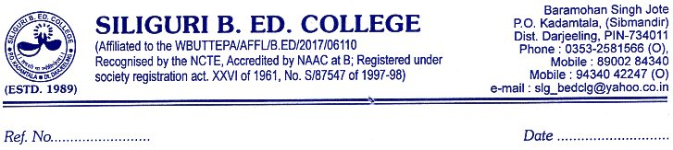

To
The Principal Secretary
Higher Education Department
Government of West Bengal
Sir
As per your direction I am submitting the following data for your kind perusal.
Name of the Suspended Employee | Name of the Office/Institution  with address | Suspended from | Reason for suspension | Any other details
**  N/A | SILIGURI B.ED. COLLEGE  BARAMOHANSINGH JOTE  P.O. KADAMTALA , DIST. DARJEELING | N/A | N/A | ***
Note: -** no such any case found from the College records till now.

*** Governing Body of the College removed Dr. Md. Golam Sabbir,Lecturer In Botany of the College) due to unauthorized absent ( without any information and permission from the college w.e.f. 08/08/2009) (as per the statue of University of North Bengal) from the service with effect from24/07/2010, which was communicated to the Director of Public Instruction vide reference no. SBC/120/2010 dated 6.8.2010.
On 24/05/2022 (forenoon) Dr. Md. Golam Sabbir , Lecturer In Botany joined the College with reference to the Writ Petition No. 3204(W) of 2011 dated 11/03/2022 from the Hon’ble High Court.
On 03/06/2022 Dr. Md. Golam Sabbir sent a email and DTDC to the Principal that he needs EXTRA ORDINARY LEAVE WITHOUT PAY on and from 05/06/2022 to 15/07/2022 , and informed that he left India .In the meeting of the Governing Body dated 06/06/2022 a resolution has been taken that his prayer will not be considered and he is directed to join the College immediately. No information has been received till now from the said Teacher End. (Copy of the Resolution is enclosed)
With thanks
Yours faithfully,
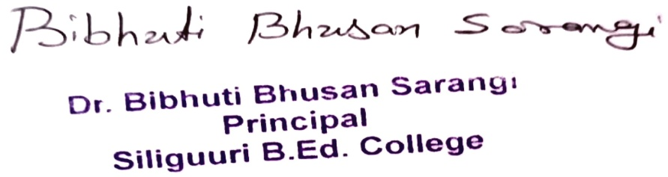

Principal, Siliguri B. Ed. College.



Sent through email on 22/06/2022
Md Golam Sabbir
Md. Golam Sabbir , Lecturer in Botany is directed to join the College immediately as he has been absent on unauthorized Leave since 04/06/2022 (though he has been informed on 08/06/2022 through email). Therefore, he is asked to join and come up with explanation for this (unauthorized Leave) by 25/06/2022. It is also decided that his pay fixation proposal will be sent to the D.P.I , W B, after he joins the college and submits the explanation report along with necessary documents to the authority.

(DR BIBHUTI BHUSAN SARANGI)

PRINCIPAL , SILIGURI B.ED. COLLEGE

